  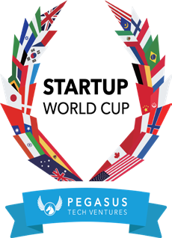

Frequently Asked Questions (FAQ) Philadelphia Startup World Cup Regional Event

**General Information**

# What is the Pegasus Tech Ventures Startup World Cup?

The Pegasus Tech Ventures Startup World Cup ([https://www.startupworldcup.io/)](http://www.startupworldcup.io/)) is a global competition that aims to support and inspire entrepreneurs worldwide. Regional winners will compete in the grand finale in San Francisco for a chance to win a $1 million investment prize.

**Participation and Benefits**

# What are the benefits of participating in the competition?

Participating startups will gain:

* Exposure: Increased visibility among investors, media, and industry leaders.
* Networking: Opportunities to connect with potential investors, mentors, and partners.
* Feedback: Valuable insights and feedback from experienced judges and investors.
* Investment: The chance to win the regional title and compete for a $1 million investment at the global finals.

# How can I apply to participate in the competition?

Startups can apply through the [Department of Commerce website.](https://phila-uyims.formstack.com/forms/the_philadelphia_regional_world_cup_pitch_competition)

# What is the Philadelphia Regional World Startup Competition application deadline?

The application deadline is September 2, 2024. Please ensure all required information is submitted by this date to be considered for the competition.

# What happens after I apply?

After submitting your application, our team of judges will review all entries. Applications will be judged by a tech advisory committee made up of industry experts and successful founders. Successful applicants will have the most clear, concise, persuasive pitch decks, have great understanding of their financials, and seek to solve a pressing problem. Selected startups will be notified on September 11, 2024 and provided with further details about their participation in the September 18 event.

# When will I find out if I am a finalist?

You will find out by Wednesday, September 11, 2024.

**Event Logistics**

# Is there any cost to participate?

No, there is no cost to apply or participate in the competition.

# Where will the regional event be held?

The regional competition will be held at Temple University, Mitten Hall on September 18, 2024 from 1:00pm until 4:00 pm.

# Can I attend the Philadelphia Regional event even if my company is not selected as a finalist?

Yes, you may attend the event if your company is not selected as a finalist. [Register here](https://www.eventbrite.com/e/philadelphia-startup-world-cup-pitch-competition-and-celebration-tickets-995704106787?aff=oddtdtcreator).

# Who can I contact for more information?

For any further questions or information, please email Tempest Carter at [Tempest.Carter@phila.gov](mailto:Tempest.Carter@phila.gov)